Walk 45 Walks around Luston Group Parishes 1
Last walked in September 2018

Description. This 6 km (3.74 mile) walk takes us out of Luston Village into the beautiful surrounding country- side. It is mainly thru fields, a short stretch along the edge of Oaker Wood and a short section takes us along Croft Lane.
Start. Townsend Park Road Luston. Explorer Map 203 Grid 486635.
Directions from Whitecross Roundabout (Turn milometer to zero). Take the A4110 Canon Pyon (Three Elms road) for 1 mile and TR at the traffic lights onto the A4103 to Worcester (Roman road). TL at the first roundabout (2 miles), onto the A49 to Leominster. Go straight across the next two roundabouts (9.5 miles then 12.5 miles) on the A49 heading towards Shrewsbury. TL at the next roundabout (13.3 miles) onto the A44 to Leominster. At 13.8 miles TR onto the B4361 towards Richards Castle. At 15.8 miles you enter Luston, and at 16.4 miles you TL and park somewhere along Townsend Park road.

1. Townsend Park road. Walk straight to the end of Townsend Park road and TL, walk along a short enclosed track and into F1. Follow the hedge on the R and continue on to cross over a stile in the top R hand corner of the field and into F2 (Ignore a stile on your R). Continue in the same direction with a hedge on your R, and on reaching the hedge corner you don’t turn R, you go straight across the field, heading towards the gap in the hedge ahead, just L of a lone oak tree. Go thru the hedge gap into F3 and continue across this field to reach hedge gaps in the far R hand corner. TR, walk a few paces and TR again, to cross over a stile into a small field F4 (electric wires are overhead). Go under the electric wires and bear slightly L to cross the field, and over another stile into F5 (Croase Farm is on your R side). Go straight up and across, heading for a lone tree in the hedgerow ahead. Walk thru a small metal gate, into an orchard and continue on to the far R hand corner where you cross a stile onto a tarmac drive.

2. Hill Top. Cross the unfenced drive into F6 and TL, then walk along the L field edge, passing to the R of Hill Top farm to go thru a small metal gate into F7. Bear slightly R as you cross this field and go thru a small metal gate into F8 . Bear slightly R and head for the bottom R hand corner, to go thru a small metal gate by a public footpath sign, and onto a road. Go straight across the road and thru a gap in the hedgerow into F9, (there is a Public Footpath signpost here, but this may be hidden), keep to the L field edge. After about 150m you TL and cross a stile, you then continue along the inside perimeter of a wood, keeping a wire fence on your L. Further on you TL over a stile and across two planks into F10. TR and follow the outside edge of the wood, now on your R. Keep straight on across the field as the wood indents to the R, to reach the R hand corner of the field, where you cross over two stiles and three planks into F11, (use the gate on the L if the stiles are over grown).

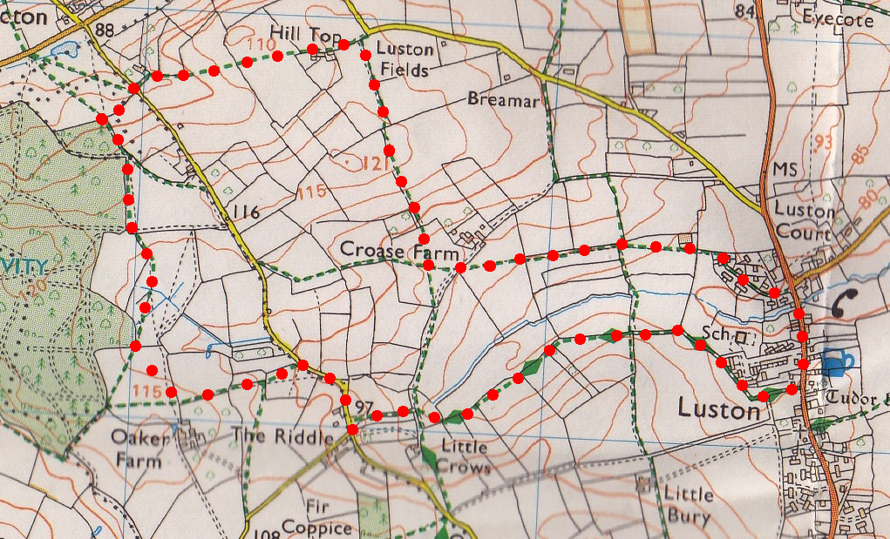
3. Two Stiles. Bear half L across this field to reach a stile that is just to the L of a power line pole (gate is to the R). Cross the stile into F12, walk thru some holy and continue along the L hand side of the field. Go thru a gate gap into F13. Bearing slightly L you cross this field to go over a stile and down wooden steps onto a road. TR, walk along the road for about 200m to reach a Public Footpath sign post (L), (this post is just before a minor road that goes off R), TL and continue down an enclosed dirt track. Go thru a kgate into F14 and bear slightly R to cross a gated wooden footbridge into F15.
1
2
3
4

4. Footbridge. TL, and walk along the L field edge to go thru a small metal gate into F16. Go along the L edge of this large field and keep to the field edge as it bends up and around to the R, (don’t go straight on thru the hedge gap in the field corner into another field). Walk on up to reach to the field corner and continue in the same direction along an enclosed green track, (ignore the stile on your L). You continue along the track to pass the school on your L and then the backs of houses. Go over a footbridge and on to end of the path and thru the gate onto the main road (opposite is The Balance Inn). TL and go down the road to TL at Townsend Park road.

